GREAT OUTDOOR PROJECT (ADD TO CART)

BY:D.RAMA TEJA REDDY

Retailer Add Item to Cart System

In an e-commerce site, a retailer or a customer chooses different products to place order for. For that, he needs to add the products to his cart. So, cart plays a very important role for placing the order in the e-commerce sites. We have tried to make the process of adding the item to cart an easier one so that the customer doesn’t find any difficulties or complexities in adding the item to the cart. The product will be added to the cart only when the credential of the retailer is correct.

Prerequisite

User must be logged in as retailer to perform the add item to cart functionality. He/she has to give his/her correct credential to add the item into the cart.

Use Case Diagram for Add Item to Cart System

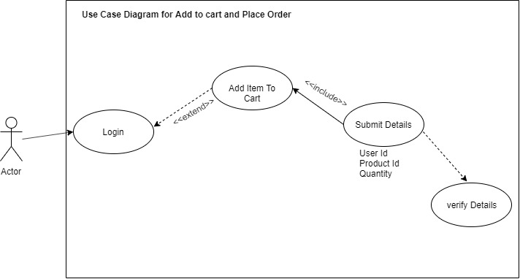

Sequence Diagram for Adding Item to cart

